// FileWriter

import java.io.FileWriter;

class Write {
public static void main(String args[]) {
String data = "Hello !! This is the data in the output file...";
try{
FileWriter output = new FileWriter("output.txt");
output.write(data);
System.out.println("Data is written to the file");
output.close();
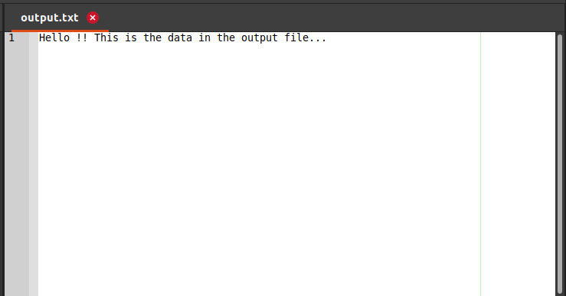
}
catch(Exception e) {
e.getStackTrace();
}
}
}

Output:

